## The Circulatory System Notes

### The Circulatory System (= The Cardiovascular System) A transport system that moves fluids through the body by the pumping of a muscular heart. Fluids distribute _____________________________, and remove metabolic wastes like ____________________.

### Parts of the Circulatory System

# Blood Contains:

* 1. Red blood cells
* major job =
* contains ____________________________________________________  
  _____________________________________.
* mature cells lack a _______________ to maximize space for hemoglobin

(increases _________________________________________ )

* 1. White blood cells
* ____________________________
* work with ________________________ to defend against infection
* larger than RBCs, but able to _____________________________________  
  ______________________________________.
  1. Platelets (cell fragments)
* release ________________, a plasma protein that forms a net-like clot over   
  injury.

*All of the above cells are ___________________________________________.

[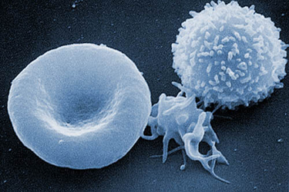](http://www.abc.net.au/science/photos/whatis/answer4.htm)

* 1. Plasma ( _________ of blood volume).

The _________________________________________ that contains water,

proteins, dissolved gases, salts, nutrients, hormones, and metabolic wastes.

# Types of Blood Vessels

1. ________________

* carry blood ___________________________
* usually carry blood with oxygen (except in pulmonary system).
* have ____________________________ so they can stretch as blood is pumped in
* branch into small ___________________

1. _______________

* carry blood _____________________________
* usually carry blood that does not have oxygen (except in pulmonary system).
* ________________, so blood moves by ______________________________ around veins.
* thinner so can _____________ to hold blood (_____ of our blood is stored in veins)
* ___________ keep blood flowing in 1 direction
* branch into small ______________

1. __________________

* smallest vessels → _______________________________________________
* connect ___________________________________
* ______________ (one cell thick) allow _______________________________

_______________________________

* only those needed are open at any given time __________________________

Route of blood flow:

heart → arteries →

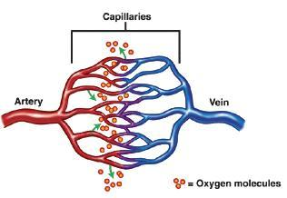

## C. The Heart

An organ made of ________________________, divided into 4 chambers for collecting and pumping blood.

The R side collects __________________________________________ and pumps it _____________________. The L side pumps _________________________.

Anatomy of the heart:

septum - ____________________________________________

2 atria (upper ____________________________________ ), atrium = singular

2 ventricles (lower ___________________________________ )

aorta (largest artery)

superior vena cava, inferior vena cava (large veins)

pulmonary artery, pulmonary vein ( _______________________________________)

SA node ( ______________________________ ) in upper R atrium wall

AV node in base of R atrium

4 valves:

AV valves – control blood flow from ________________________________

semilunar valves – control blood flow from ________________________________

**Diagram of the Heart**

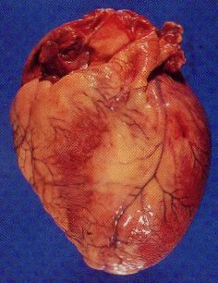 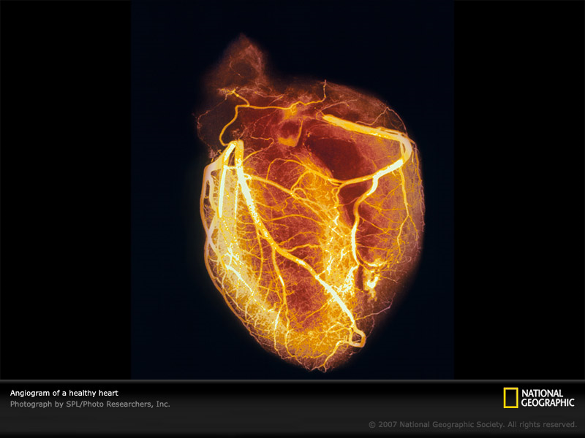

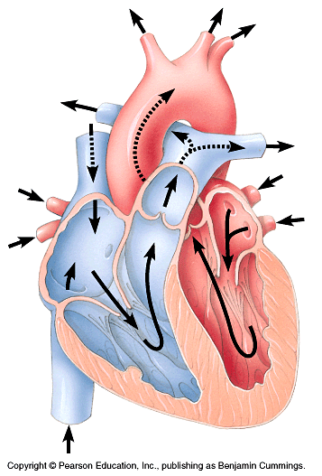

**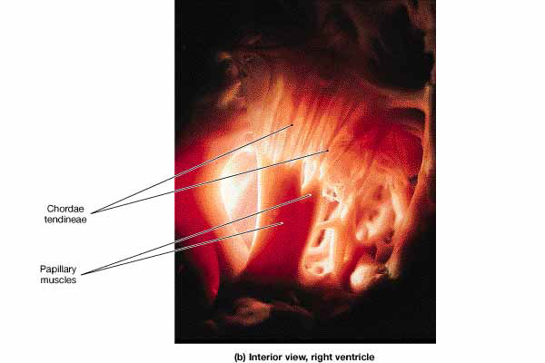 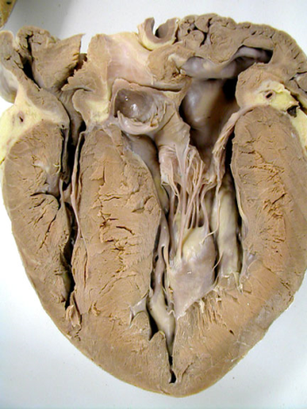   
 AV valve showing tendons**

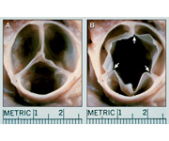

**Semilunar valve closed and open**

**III. Functions of the cardiovascular system**

= to oxygenate all cells using two pathways: _________________________________

____________________________

# Pulmonary circuit: the path of blood from R side of the heart (O2 poor), to lungs, back to the heart with O2 rich blood.

Deoxygenated blood ___________

→ ________________________ (CO2 is released, O2 diffuses in)

* O2 rich blood enters ________________

→

# Systemic circuit: path of blood from the heart to the body (with O2) and back to the heart (with no O2).

Oxygenated blood in _______________

→ thru AV valve

* out semilunar valve
* ______________ (away from heart) transport blood to the heart, head and arms, abdomen, and legs.
* capillaries in body ( _______________________________ )
* ______________ (going back to heart)
* blood from the upper body returns to he heart thru _________________________;

from the lower body returns thru the __________________________________.

**The Pulmonary and Systemic Circuits Diagram:**



**IV. Control of Heartbeat and Blood Pressure**

**A. The Cardiac Cycle**

The __________________ (pacemaker) sets the rate for contraction of all cardiac   
 muscle cells.

1. SA node in _____________________ generates an ______________________

making both __________________ contract in unison.

1. Impulse is passed to the ____________________ (base of R atrium). Impulses are

___________________________ to ensure blood in atria has emptied completely into ventricles.

1. Impulse in AV node causes ______________________________________ - drives blood into arteries.
2. _________________________ during contraction to prevent backflow of blood.
3. Heart sounds (“lub-dup”) come from the recoil of blood against __________________.
4. Rate is controlled by two sets of ______________ surrounding the pacemaker – one speeds heartbeat up, the other slows it down.
5. Also controlled by _________________ (epinephrine, the “fight or flight” hormone),

and _____________________ – an increase in ________ raises heart rate by

_______________________.

**B. Pulse Rate and Blood Pressure**

1. Pulse Rate

When blood surges into arteries their elastic walls stretch, but almost immediately snap back. ______________________________________________________ ____________________

2. Blood Pressure = the pressure of blood against the wall of a blood vessel.

* + when ventricles contract, blood flows thru arteries increasing pressure inside

= ____________________________________

* + when ventricles relax the pressure is lowest = _____________________
  + when blood enters capillaries it encounters so much resistance that the pumping of the heart doesn’t have much affect anymore.

3. BP is measured by________________________________ (= a blood pressure cuff)

### V. Fitness and Heart Rate

* Blood pressure and heart rate increase when a person moves from reclining to standing to ________________________________________.
* They also increase with increase in activity to supply additional oxygen to cells.
* Hearts of people who are physically fit pump a ____________________________ ________________________________________, so increases in heart rate and BP will be smaller in fit people than in non-fit people undergoing the same activity.
* Fit people also require less time for their heart rate and BP to return to normal after exercising = ________________________________

**VI. Cardiovascular Disease**

More than _________ of health related deaths in US come from this.

1. Heart attacks - **________________________________________________** due to lack of oxygen from **______________________________________________________________**.   
   Causes **______________________** = pain that shoots down L arm/chest.

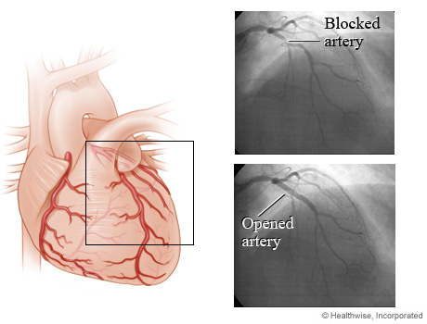 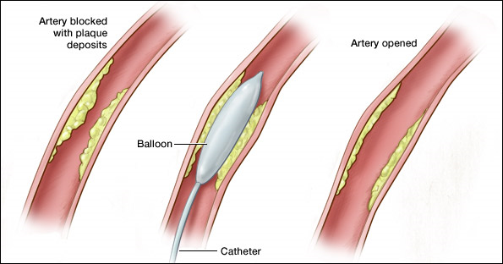

Blocked and opened coronary artery. Balloon angioplasty to open blocked artery.

1. Stroke - **________________________________________________________** due to a small **__________________________________________________** Results in **_________________**  
   **____________________________________________________**. Signs of stroke include numbness in hands/face, difficulty speaking, etc.
2. Atherosclerosis – an accumulation of **___________________________________________ ________________________________________________** . This begins in early adulthood but does not appear until later in life. Associated with **___________________________**  
   **_______________________________________________________**.

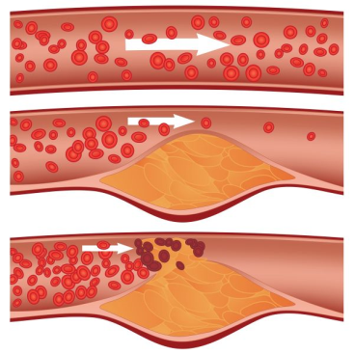 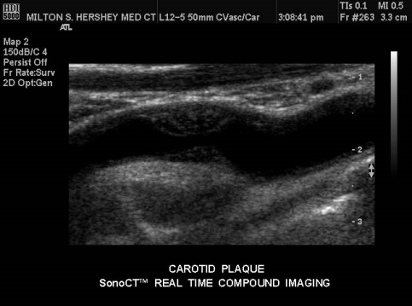   
 How plaque builds up in an artery. Ultrasound of an artery showing plaque.

1. Hypertension = **___________________________________________**. Blood moves thru the arteries with a higher than normal pressure ( **_________________** ). Associated with atherosclerosis, **__________________________________________________________**

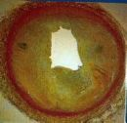 Plaque build-up leads to high blood pressure.